Interpret and Represent Multiplication and Division in Context

Lesson 1

1. 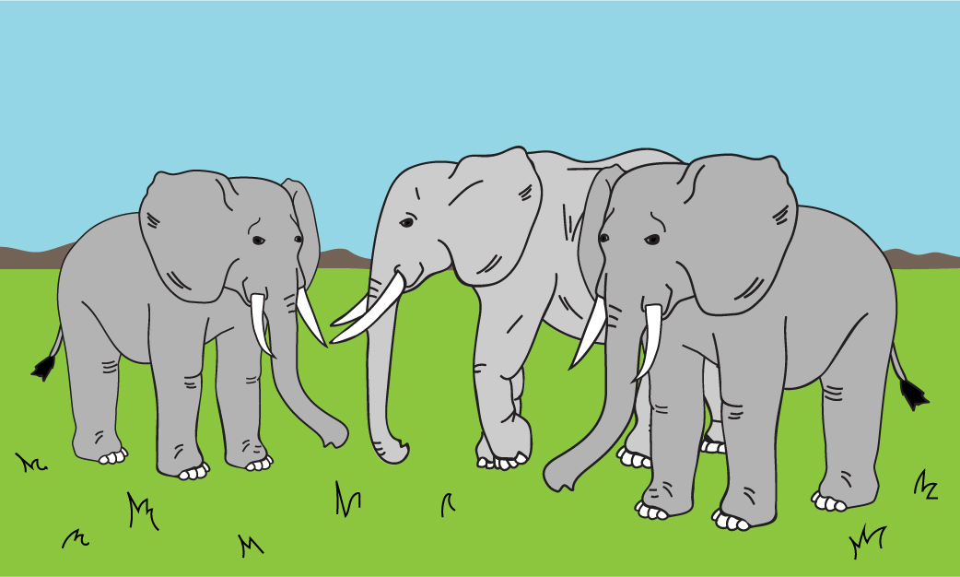Write the repeated-addition equation to represent the total number of tusks on all three elephants.

$+$ $+$ $=$____________________________________________  
number of tusks on one elephant number of tusks on one elephant number of tusks on one elephant total tusks for all three elephants

1. Write the multiplication equation to represent the total number of tusks on all three elephants. $×$ $=$
     
     
     
   ___________ ___________ ___________  
    number of elephants number of tusks on one elephant total tusks for all three elephants
2. Model the total number of tusks on all three elephants with repeated grouping.

1. Use the number line to model the total number of tusks on all three elephants with skip counting.

0

1

2

3

4

5

6

7

8

9

1. 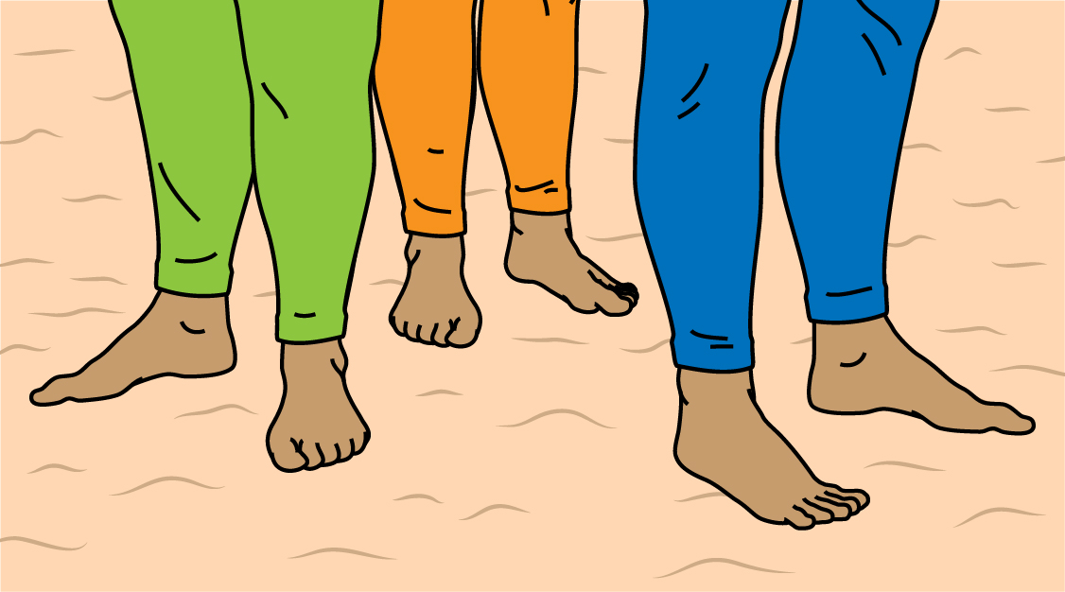Write the repeated-addition equation to represent the total number of toes on all three surfers.

1. Write the multiplication equation to represent the total number of toes on all three surfers.

1. Model the total number of toes on all three surfers with repeated grouping.

1. Use the number line to model the total number of toes on all three surfers with skip counting.

1. 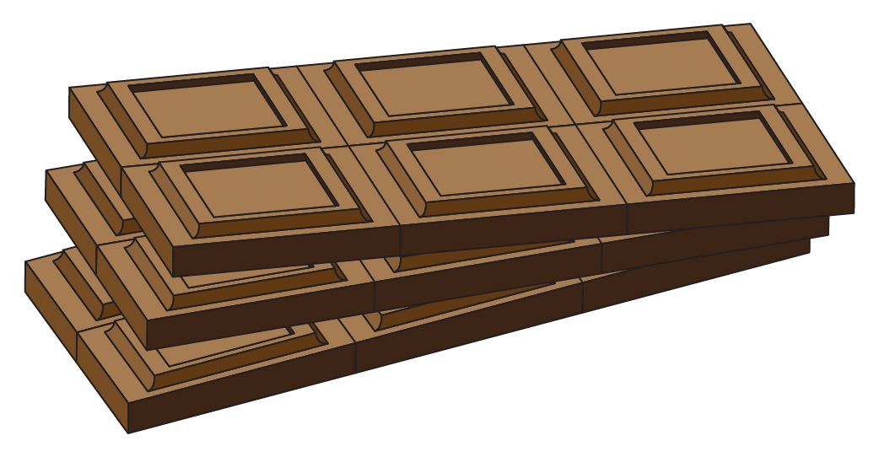Write an equation representing the following picture.
2. Draw a picture to represent $4 × 3$.

Interpret and Represent Multiplication and Division in Context

INSTRUCTIONAL ACTIVITY SUPPLEMENT

Lesson 1

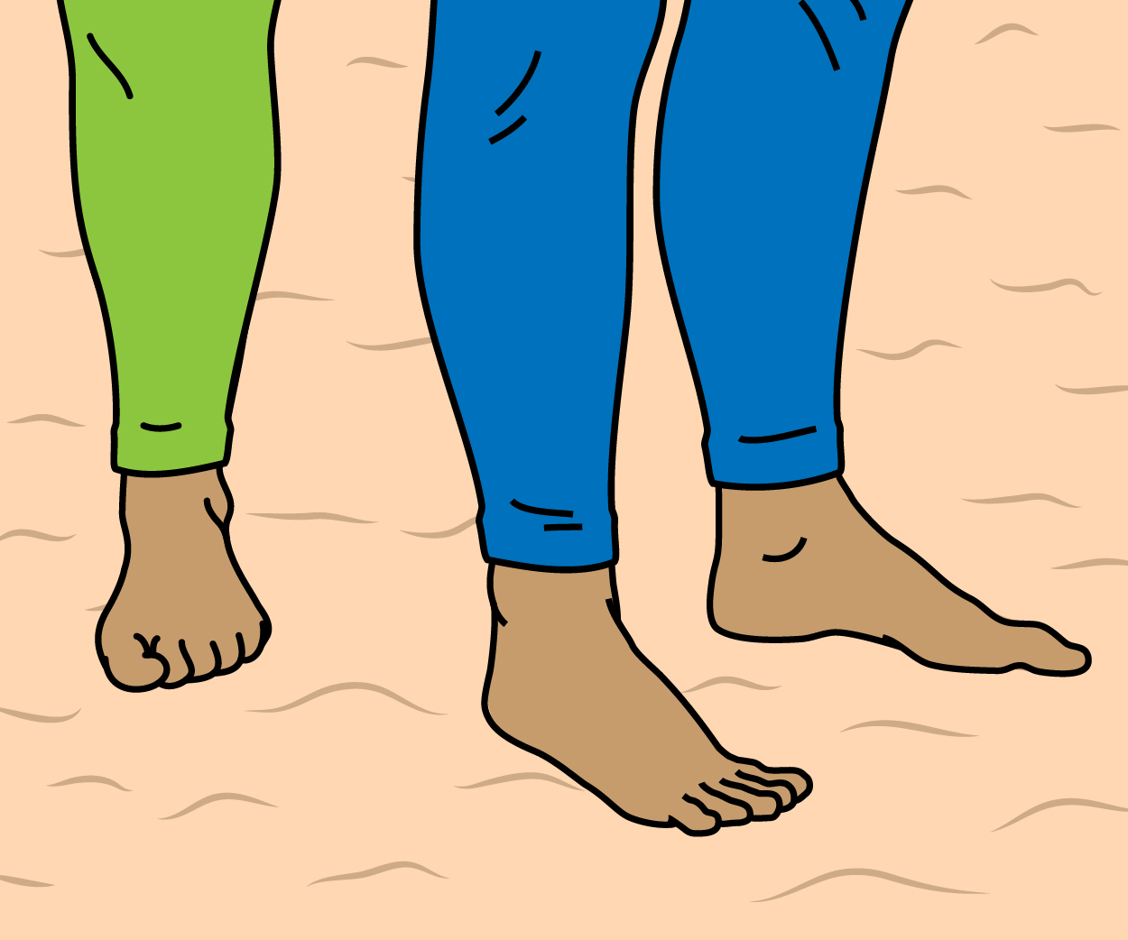

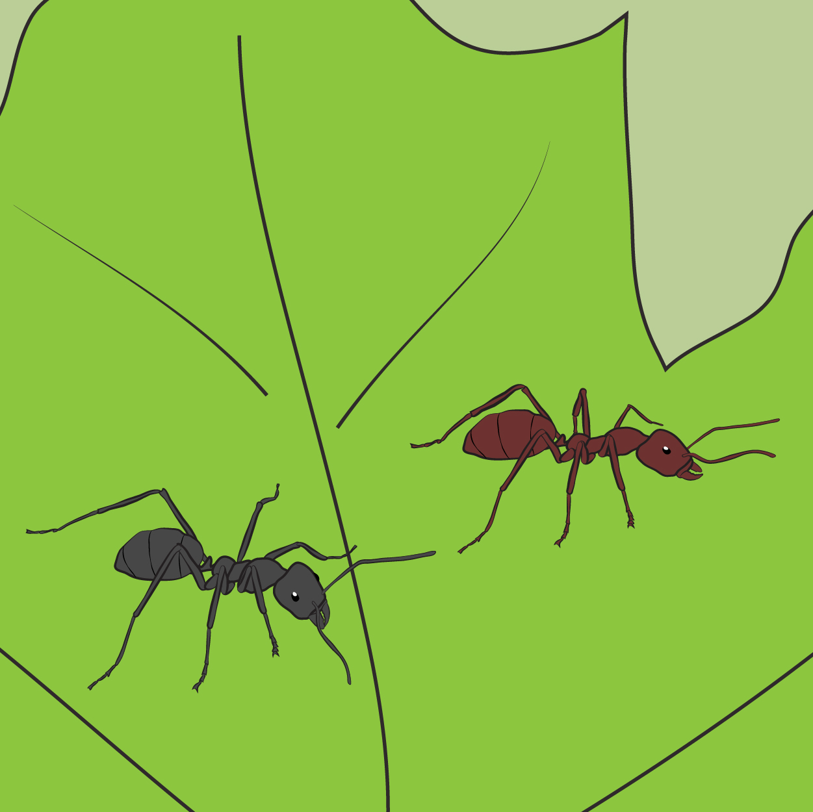

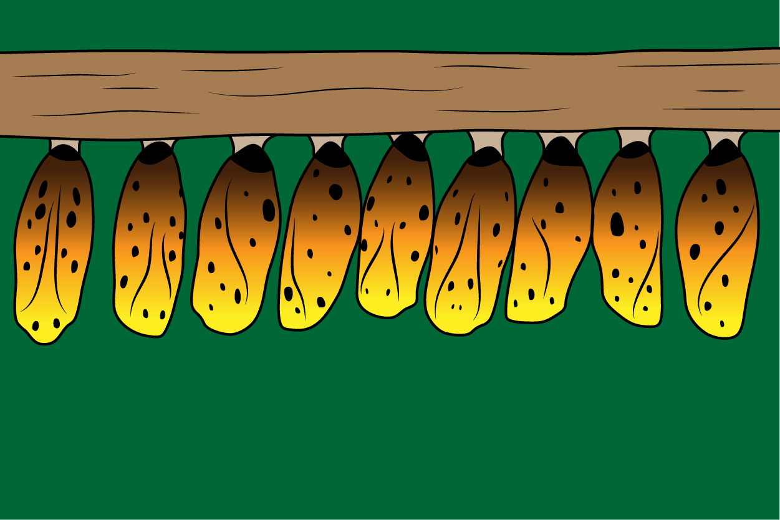

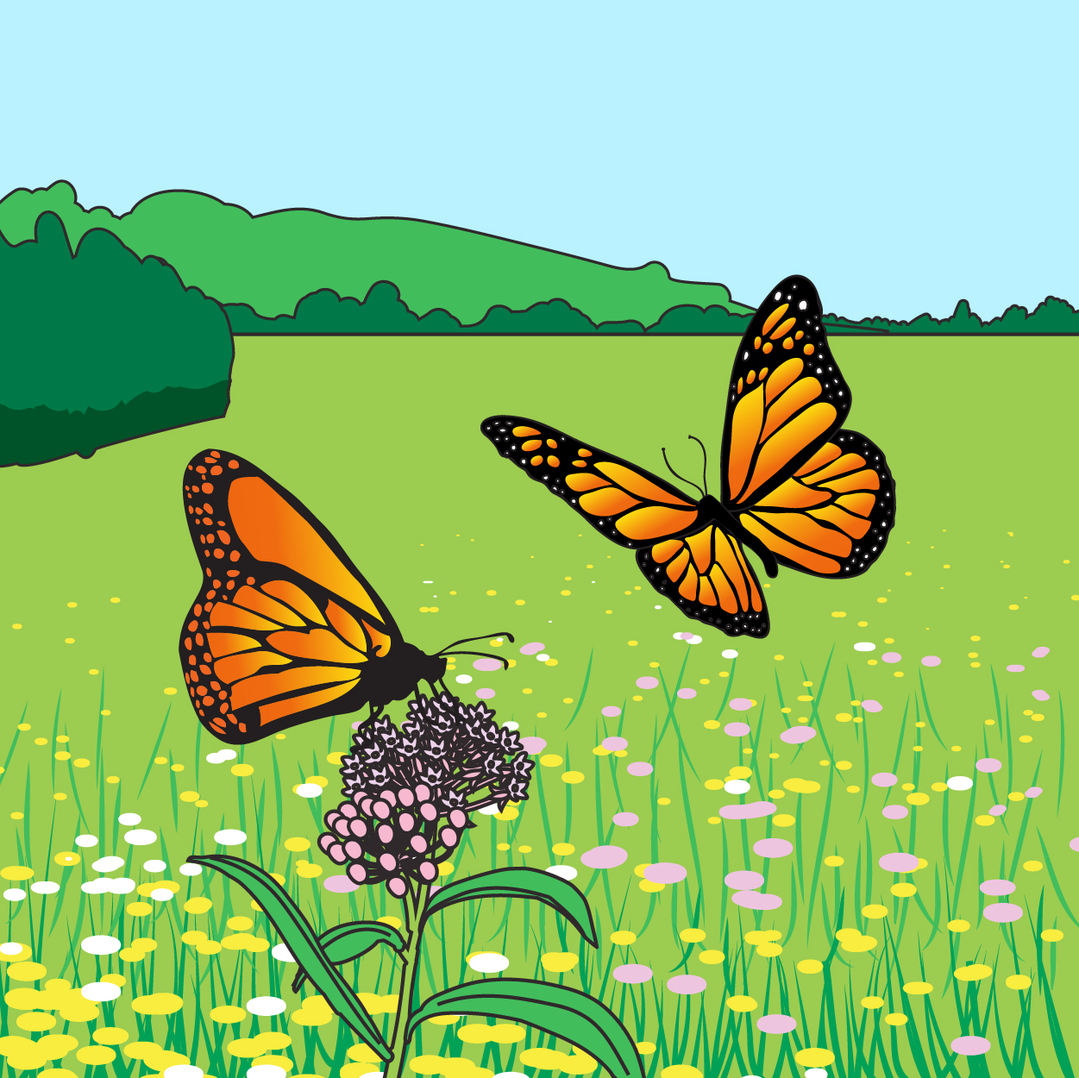

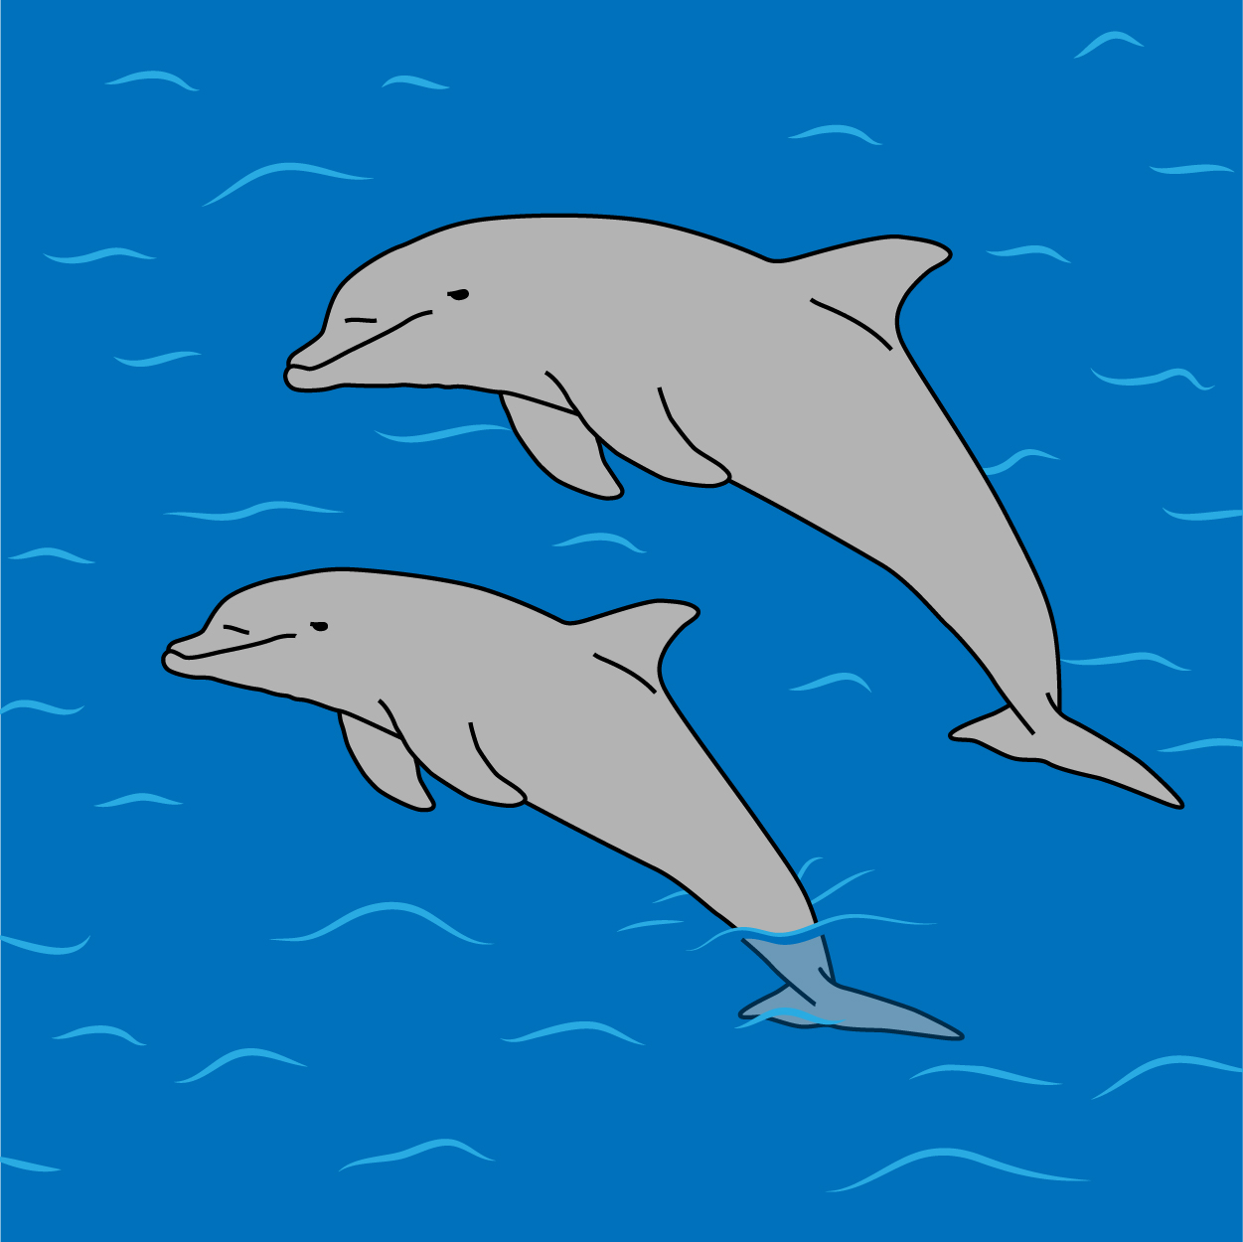

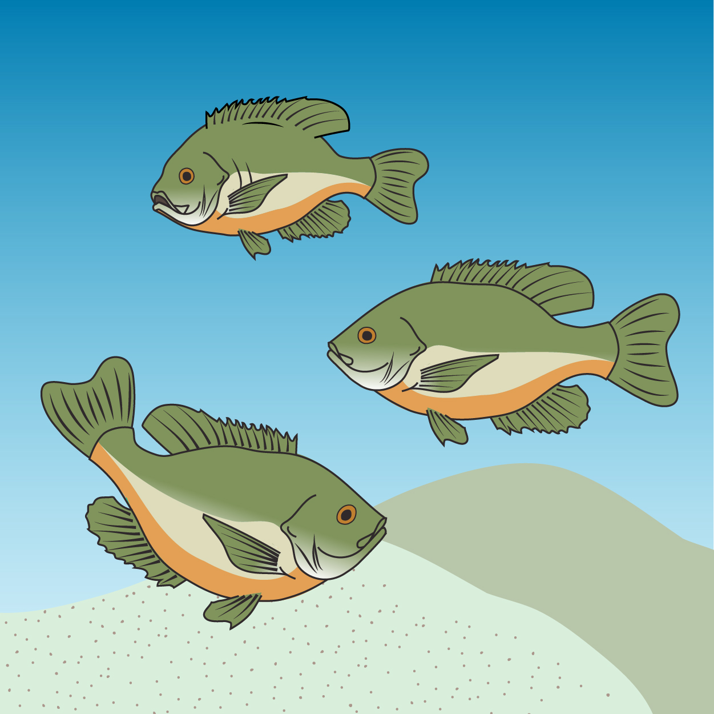







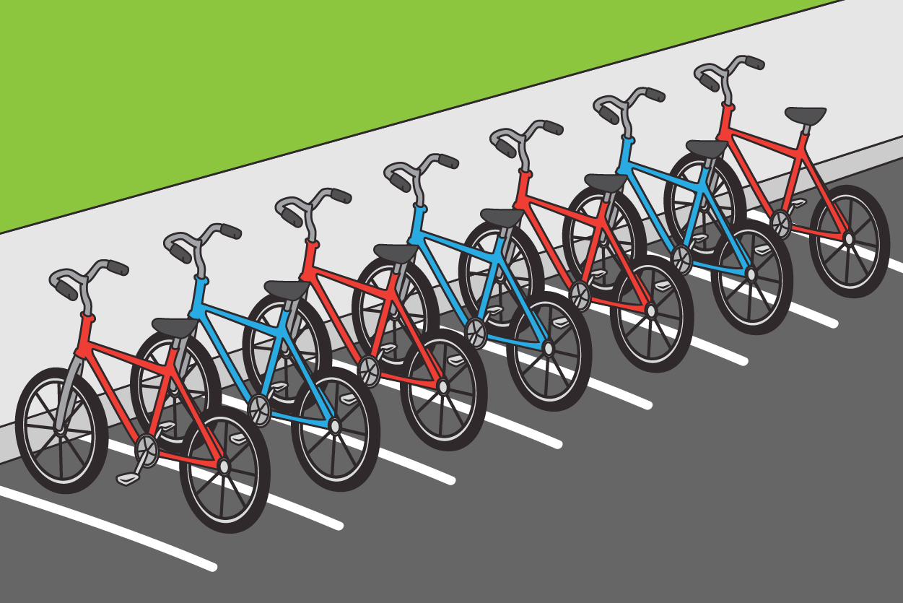

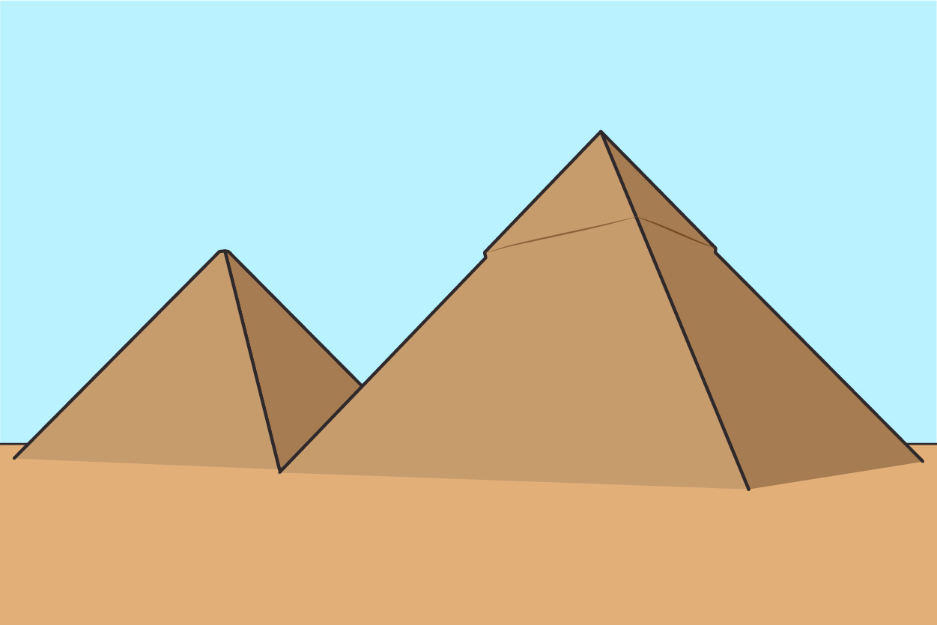

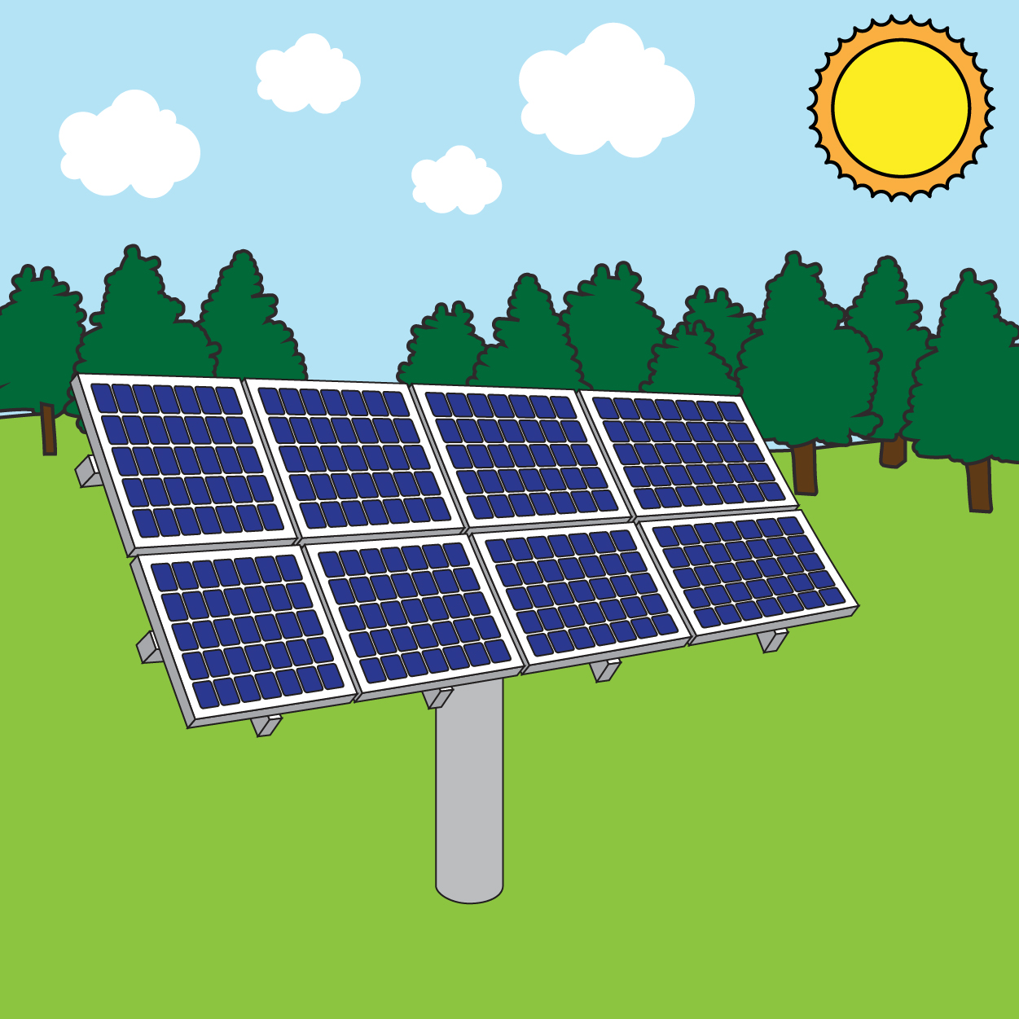



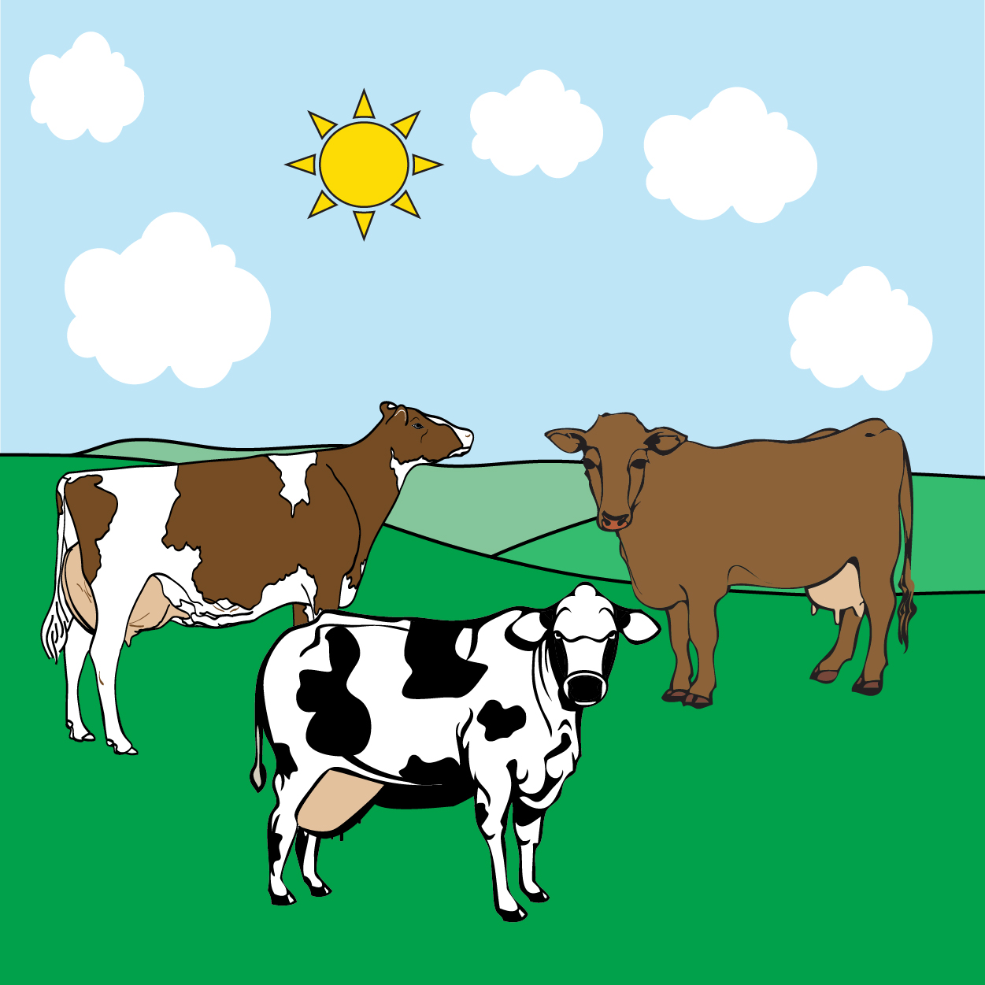

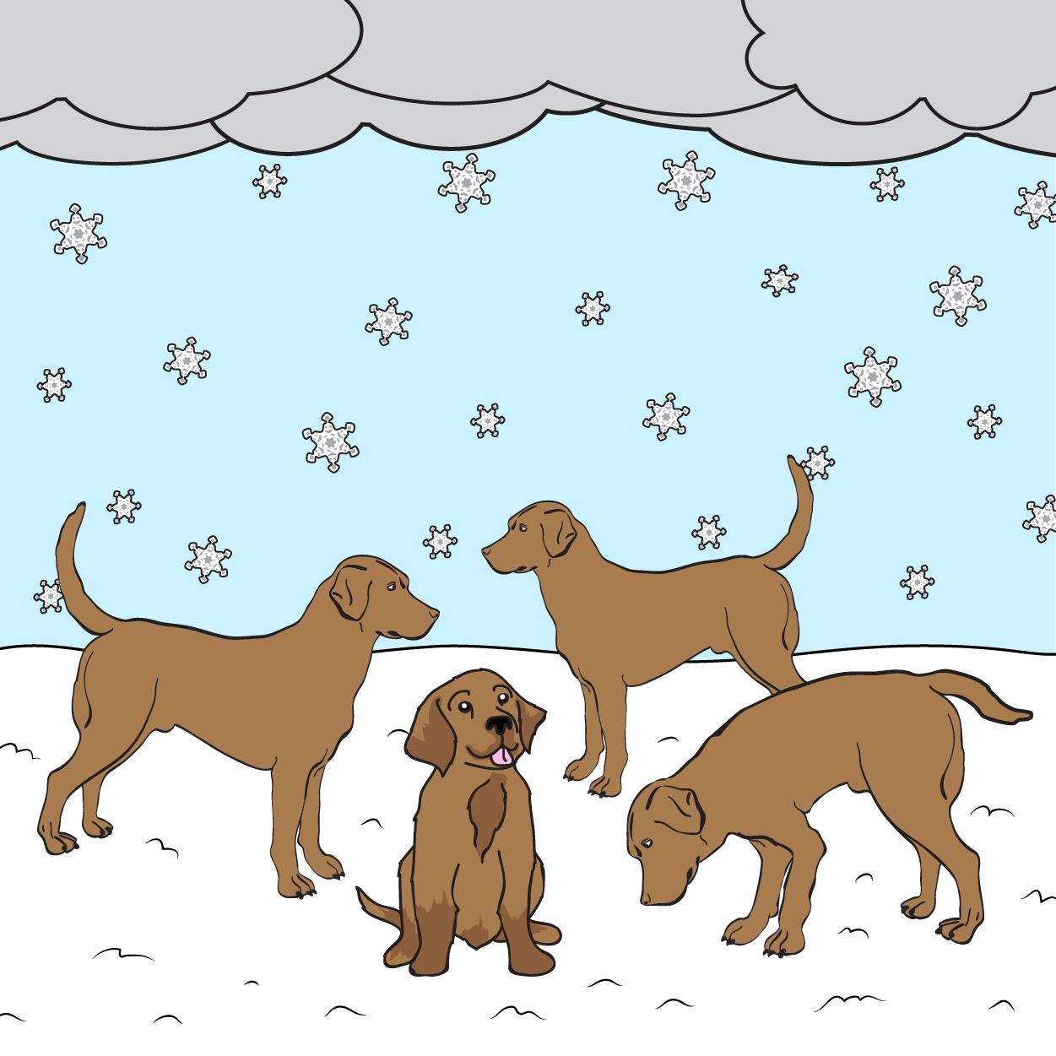

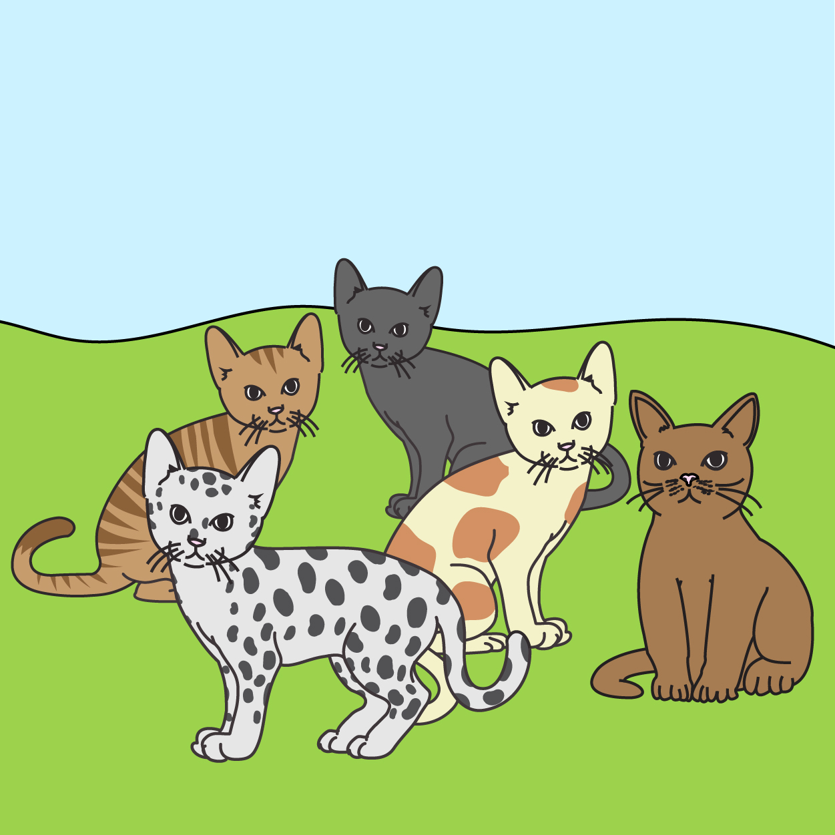

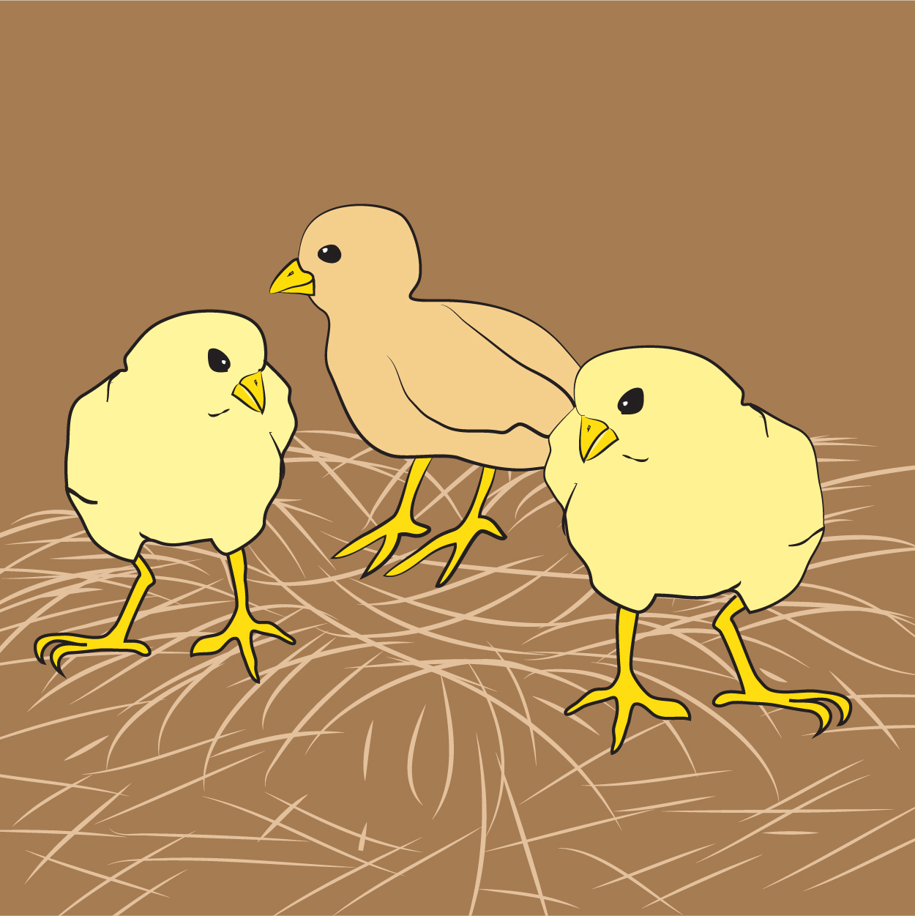

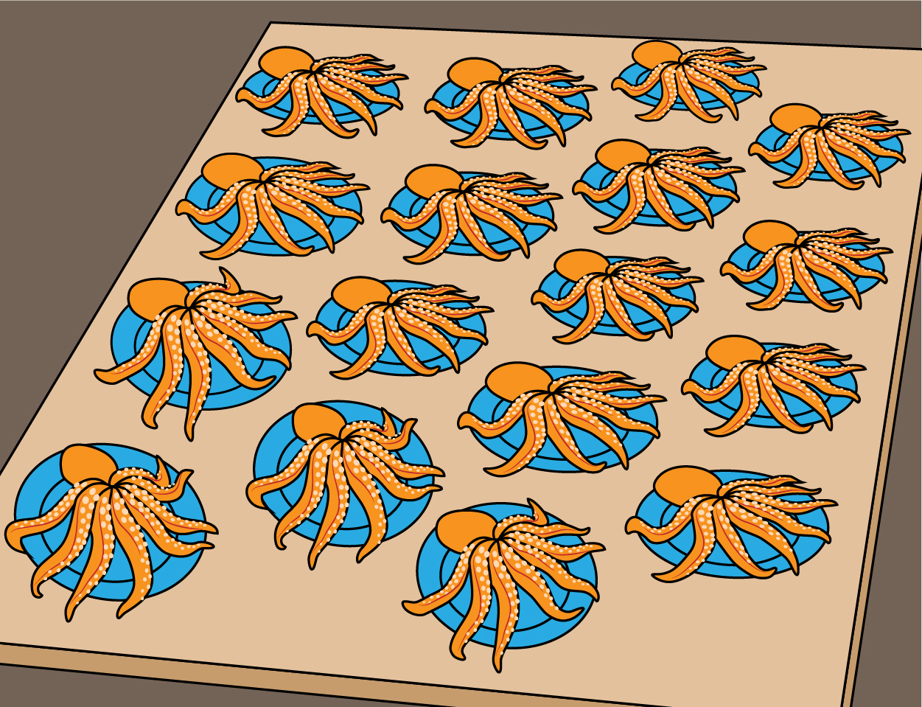

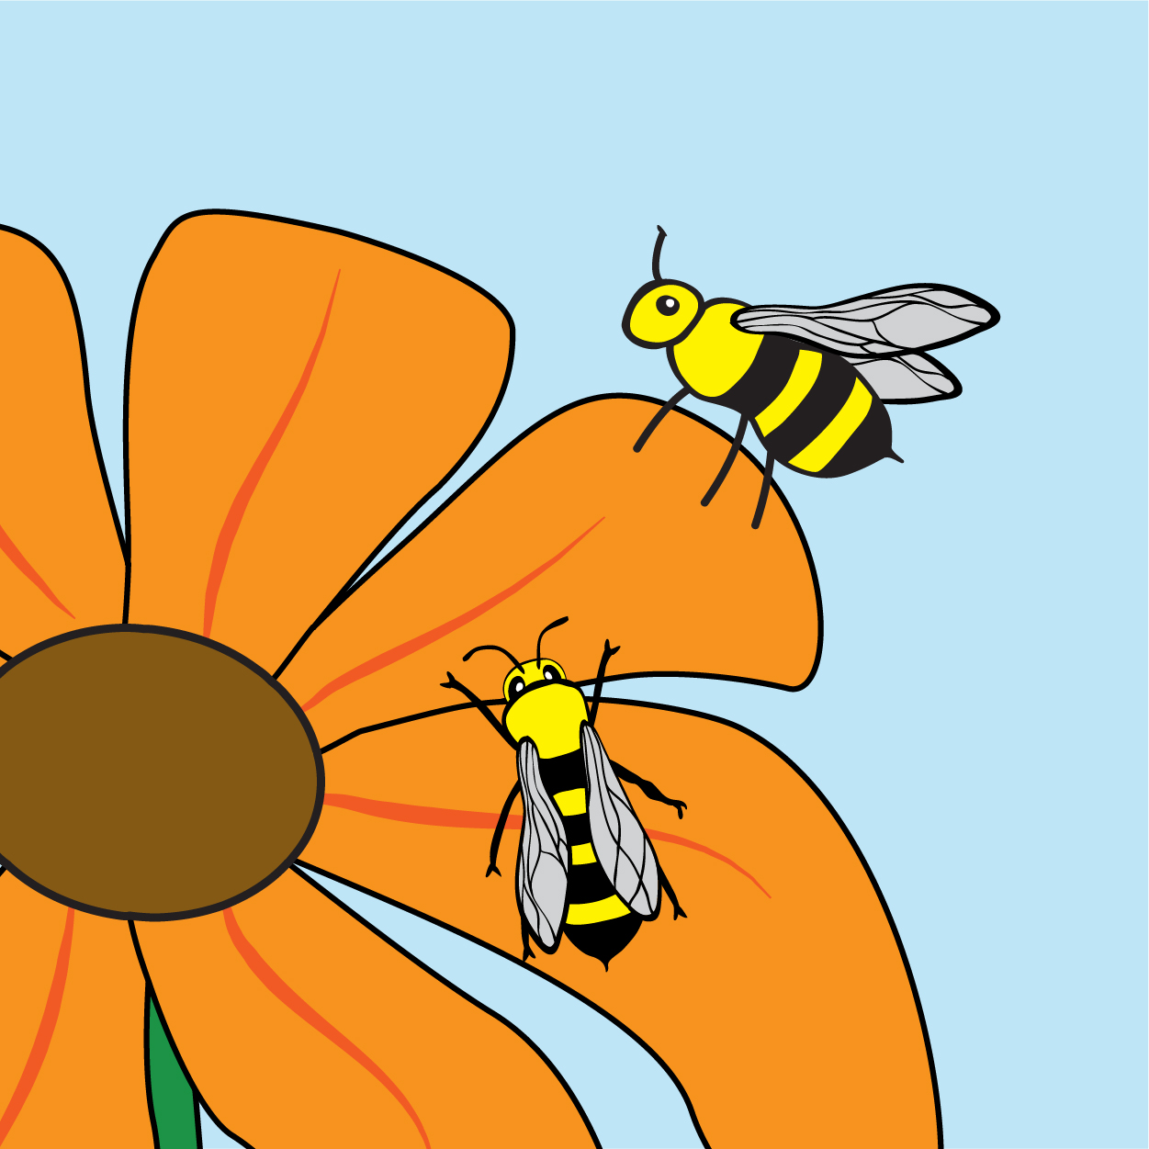

Interpret and Represent Multiplication and Division in Context

Lesson 2

Three siblings—Alyssa, Molly, and Joseph—each picked five apples at the orchard. How many total apples did the siblings pick?

Identify each component of the story problem by filling in the following table with phrases from the story problem.

|  |  |
| --- | --- |
| Character: | Action: |
| Setting: | Problem: |

Represent the scenario in the following ways.

|  |  |
| --- | --- |
| Addition Sentence: | Multiplication Sentence: |
| Repeated grouping: | Array: |
| Skip Counting: | |

A peach orchard is being planted next door. There will be 10 rows, each containing seven peach trees. How many peach trees are being planted?

Identify each component of the story problem by filling in the following table with phrases from the story problem.

|  |  |
| --- | --- |
| Character: | Action: |
| Setting: | Problem: |

Represent the scenario in the following ways.

|  |  |
| --- | --- |
| Addition Sentence: | Multiplication Sentence: |
| Repeated grouping: | Array: |
| Skip Counting: | |

Kayla picked 12 apples at the apple orchard. Chelsea picked three times as many apples. How many apples did Chelsea pick?

Identify each component of the story problem by filling in the following table with phrases from the story problem.

|  |  |
| --- | --- |
| Character: | Action: |
| Setting: | Problem: |

Represent the scenario in the following ways.

|  |  |
| --- | --- |
| Addition Sentence: | Multiplication Sentence: |
| Repeated grouping: | Array: |
| Skip Counting: | |

The dimensions of Jason’s vegetable garden are 12 feet wide by five feet long. What is the total area of Jason’s garden?

Identify each component of the story problem by filling in the following table with phrases from the story problem.

|  |  |
| --- | --- |
| Character: | Action: |
| Setting: | Problem: |

Represent the scenario in the following ways.

|  |  |
| --- | --- |
| Addition Sentence: | Multiplication Sentence: |
| Repeated grouping: | Array: |
| Skip Counting: | |

Dean wants to bake a pie with the fruit he picked. He can choose from four different fruits and two different piecrusts. If he only chooses one crust and one pie filling, how many different kinds of pie can he make?

Identify each component of the story problem by filling in the following table with phrases from the story problem.

|  |  |
| --- | --- |
| Character: | Action: |
| Setting: | Problem: |

Represent the scenario in the following ways.

|  |  |
| --- | --- |
| Addition Sentence: | Multiplication Sentence: |
| Repeated grouping: | Array: |
| Skip Counting: | |

Interpret and Represent Multiplication and Division in Context

INSTRUCTIONAL ACTIVITY SUPPLEMENT

Lesson 2

Three muffin tins are being baked in the oven. Each muffin tin contains 12 muffins. How many muffins will there be in total?

**Word Bank:**

Problem

Event/Action

Setting

Character

|  |  |
| --- | --- |
| Addition Sentence: | Multiplication Sentence: |
| Repeated grouping: | Array: |
| Skip Counting: | |

Interpret and Represent Multiplication and Division in Context

INSTRUCTIONAL ACTIVITY SUPPLEMENT

Lesson 3

Write your story problem here. Include a picture to illustrate the story problem. Do not include the solution on this page.

Represent your story problem with an array.

Represent your story problem with skip counting.

Represent your story problem with repeated grouping.

Represent your story problem with repeated addition.

Represent your story problem with a multiplication equation. Include the solution.

Interpret and Represent Multiplication and Division in Context

INSTRUCTIONAL ACTIVITY SUPPLEMENT

Lesson 3

Story-problem checklist:

☐ It is clear how many groups there are.

☐ The question requires multiplication, not addition.

☐ The groups are equally sized.

☐ The first number represents the number of groups, and the second number represents the size of each group.

☐ Specific vocabulary is used (avoided the word “groups”).

☐ The story problem is realistic.

☐ The story problem is interesting.

☐ The story problem does not contain the answer.

Interpret and Represent Multiplication and Division in Context

Lesson 4

You have 56 pieces of candy to hand out as favors at your party, and you want to give each person four pieces of candy.

1. What is the *divisor* in this situation? How do you know?
2. What is the *dividend* in this situation? How do you know?
3. Write the division expression that represents this situation.
4. Tell how many people can get party favors. Explain your reasoning with words or a model.
5. Write the division equation with the quotient.

Mr. Zimmerman needs to distribute equal-size pieces of ribbon to his students for a class project. He bought a ribbon that is 36 inches long. If there are 18 students in his class, what length of ribbon will each student get?

1. What is the *divisor* in this situation? How do you know?
2. What is the *dividend* in this situation? How do you know?
3. Write the division expression that represents this situation.
4. Tell what length of ribbon each student receives. Explain your reasoning with words or a model.
5. Write the division equation with the quotient.

Interpret and Represent Multiplication and Division in Context

INSTRUCTIONAL ACTIVITY SUPPLEMENT

Lesson 5

Write your story problem here. Don’t include the solution on this page—only provide the answer on the reverse side.

Represent your story problem with an array.

Represent your story problem with skip counting.

Represent your story problem with repeated grouping.

Represent your story problem with a division equation. Show the quotient.

Interpret and Represent Multiplication and Division in Context

INSTRUCTIONAL ACTIVITY SUPPLEMENT

Lesson 5

**Story problem checklist:**

☐ It is clear how many groups there are.

☐ The question requires division, not subtraction.

☐ The groups are equally sized.

☐ The first number represents the total number of items, and the second number represents either the number of groups or the size of each group.

☐ Specific vocabulary is used (avoided the word “groups”).

☐ The story problem is realistic.

☐ The story problem is interesting.

☐ The story problem does not contain the answer.

Interpret and Represent Multiplication and Division in Context

INSTRUCTIONAL ACTIVITY SUPPLEMENT

Lesson 6

**Problem #1**

Represent the story problem with an array.

Represent the story problem with repeated grouping.

Represent the story problem with skip counting.

Represent the story problem with an illustration.

Represent the story problem with an equation. Include the answer.

**Problem #2**

Represent the story problem with an array.

Represent the story problem with repeated grouping.

Represent the story problem with skip counting.

Represent the story problem with an illustration.

Represent the story problem with an equation. Include the answer.

**Problem #3**

Represent the story problem with an array.

Represent the story problem with repeated grouping.

Represent the story problem with skip counting.

Represent the story problem with an illustration.

Represent the story problem with an equation. Include the answer.

**Problem #4**

Represent the story problem with an array.

Represent the story problem with repeated grouping.

Represent the story problem with skip counting.

Represent the story problem with an illustration.

Represent the story problem with an equation. Include the answer.

**Problem #5**

Represent the story problem with an array.

Represent the story problem with repeated grouping.

Represent the story problem with skip counting.

Represent the story problem with an illustration.

Represent the story problem with an equation. Include the answer.

Interpret and Represent Multiplication and Division in Context

Lesson 1-6

1. Consider the following array:  
     
     
   1. Write the multiplication equation that the array represents.
   2. The number of groups in a multiplication problem is called the multiplier. What is the multiplier in this scenario?
   3. The group size in a multiplication problem is called the multiplicand. What is the multiplicand in this scenario?
2. Consider the following number line:

0

7

14

21

28

* 1. Write the division equation that the number line represents.

* 1. How many groups does the number line represent?

* 1. What dividend is represented by the number line?

1. Four students each bring three bags of candy to the class Halloween party. How many total bags of candy are there? Represent this scenario with the following models.
   1. An array

* 1. Repeated grouping

* 1. Symbolic form

1. Write a story problem to represent $6 × 2$.

1. A music teacher has 45 feet of ribbon. She wants to cut it into nine-foot sections for the Maypole dance. How many sections will there be? Represent this scenario with the following models.
   1. Repeated subtraction on a number line

* 1. An array
  2. Symbolic form

1. 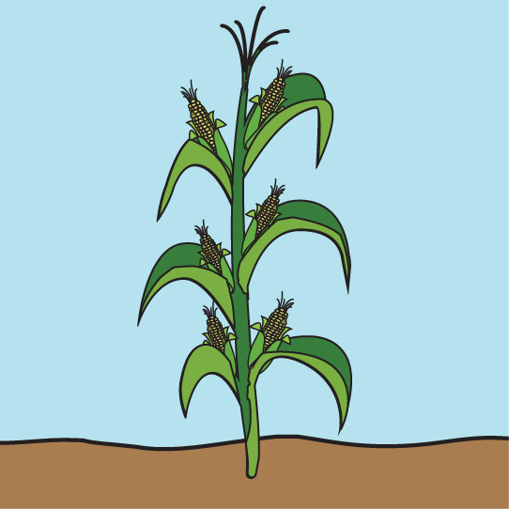Mr. McGregor is planting his garden. He has 24 vegetable plants and wants to plant them in four rows.
   1. How many vegetable plants will be in each row?

* 1. Label and fill in all the missing components of the division problem representing this situation. $$24÷6=☐$$

Quotient

* 1. Mr. McGregor realized that his garden does not have room for six rows. Draw and explain another rectangular arrangement besides six rows for planting his 24 vegetables.